# **WEEK 6 React HANDS ON**

**SUBMITTED BY :-**

NAME – AYUSH SAHOO

SUPERSET ID – 6372243

COURSE – DIGITAL NURTURE 4.0 JAVA FSE

EMAIL – [ayush.sahoo003@gmail.com](mailto:ayush.sahoo003@gmail.com)

COLLEGE – C.V. RAMAN GLOBAL UNIVERSITY

**-----------------NOTE: I HAVE ALSO DONE ADDITIONAL IMPORTANT HANDS ON -------------------**

**MANDATORY HANDS ON**

**EXERCISE 1:**

**Create a new React Application with the name “myfirstreact”, Run the application to print “welcome to the first session of React” as heading of that page.**

**SOLUTION:-**

Step 1: Download “NodeJs” and “npm”.

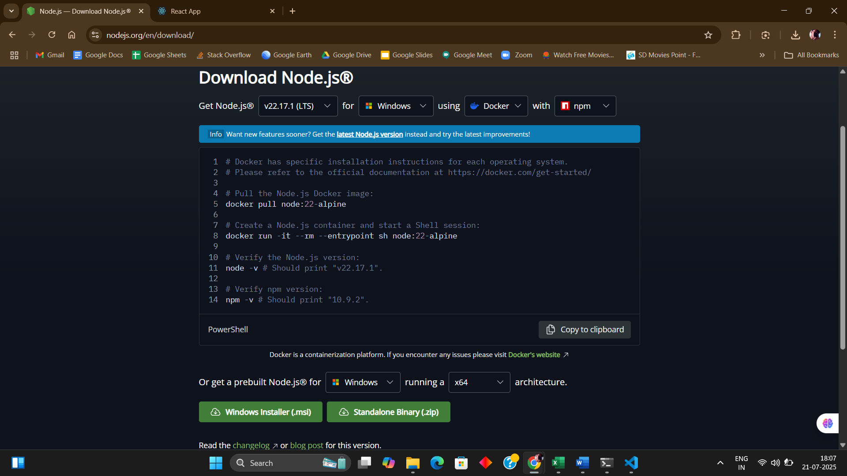

Step 2: C:\Users\ayush>npm install -g create-react-app

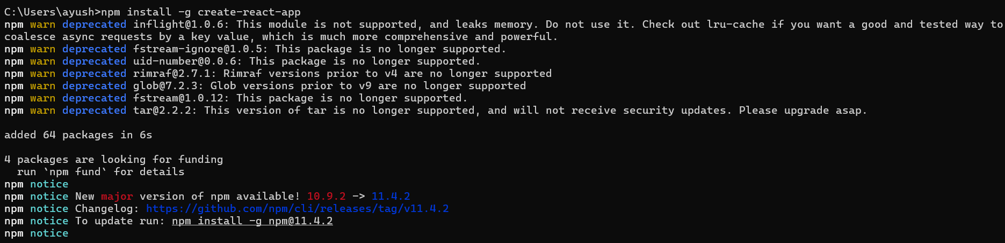

Step 3: C:\Users\ayush>npx create-react-app myfirstreact

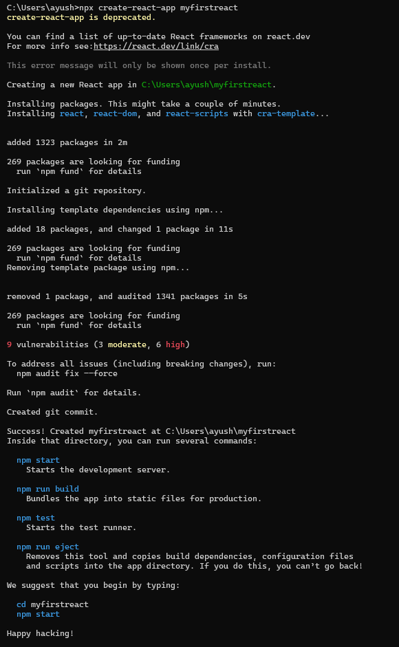

Step 4: cd myfirstreact



Step 5: In “app.js” file in src folder of “myfirstreact”.

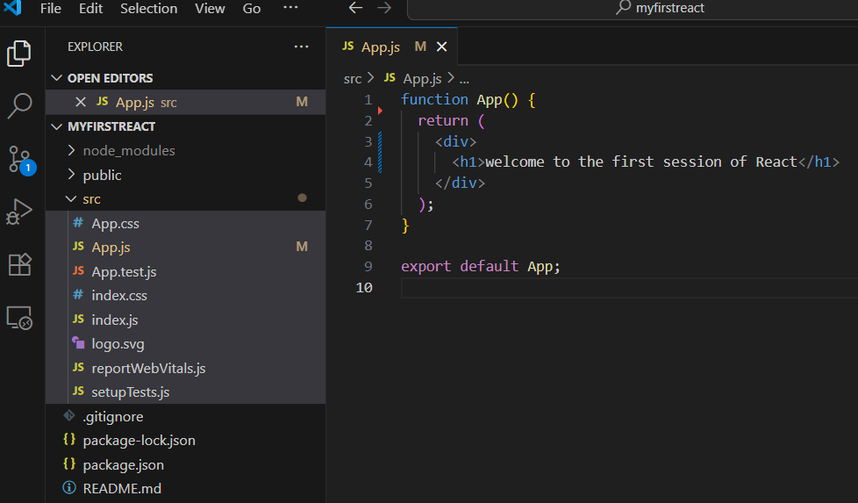

Step 6: open “localhost:3000”.

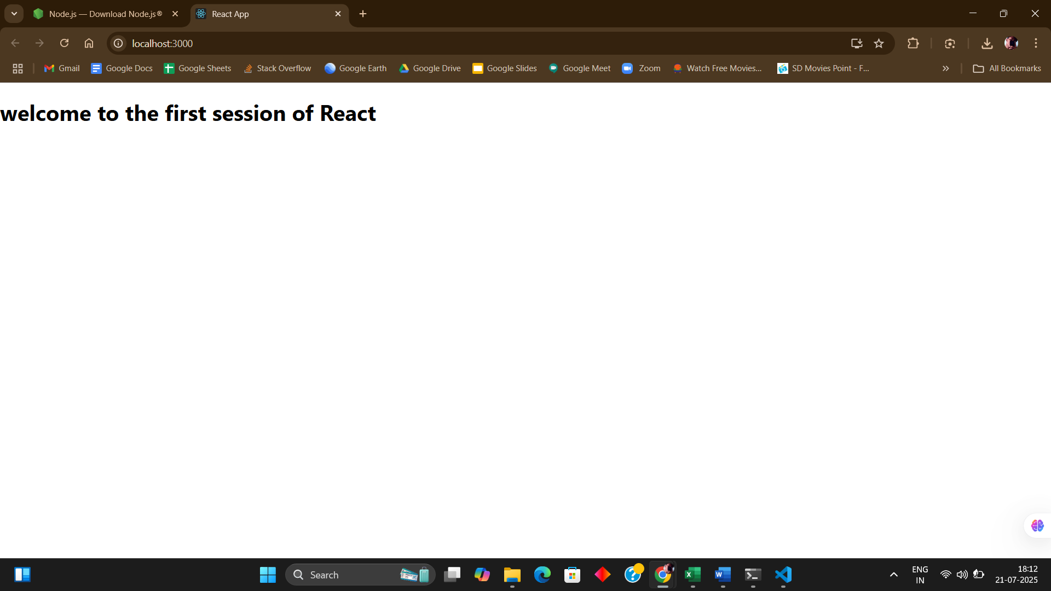

**EXERCISE 2: Create a react app for Student Management Portal named StudentApp and create a component named Home which will display the Message “Welcome to the Home page of Student Management Portal”. Create another component named About and display the Message “Welcome to the About page of the Student Management Portal”. Create a third component named Contact and display the Message “Welcome to the Contact page of the Student Management Portal”. Call all the three components.**

**SOLUTION:**

Step 1: C:\Users\ayush>npx create-react-app studentpp.

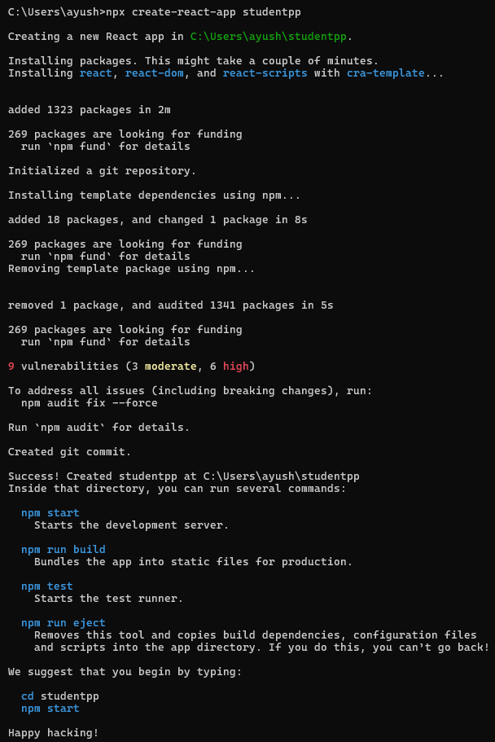

Step 2: Create a folder in src by name of “components” and in that create 3 files naming ”Home.js”, “About.js” and “Contact.js”.

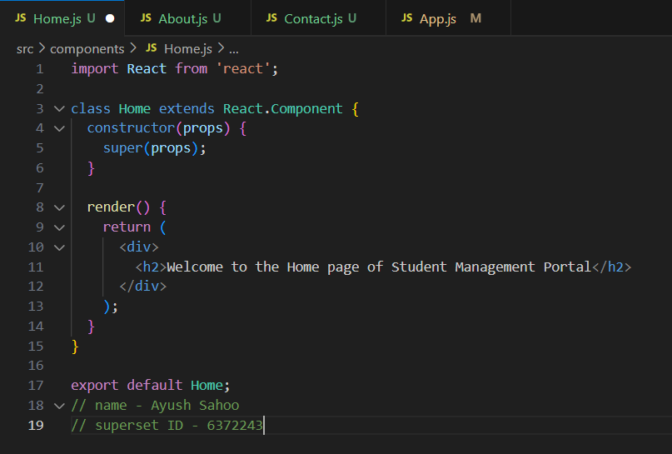

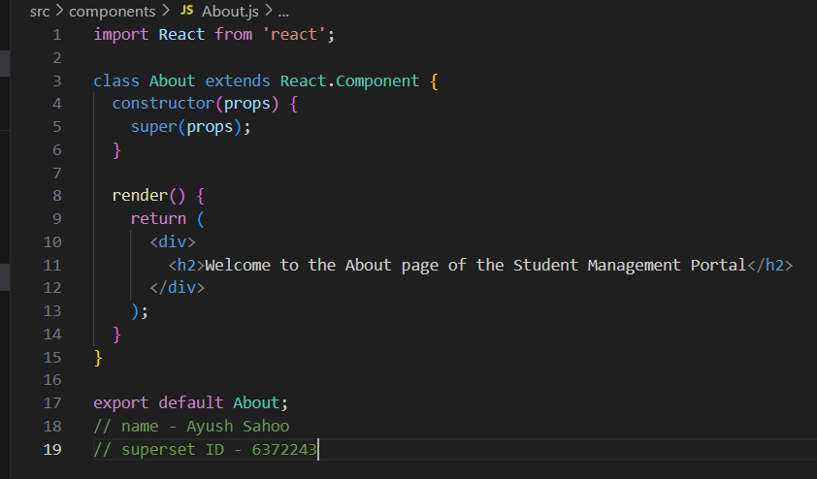

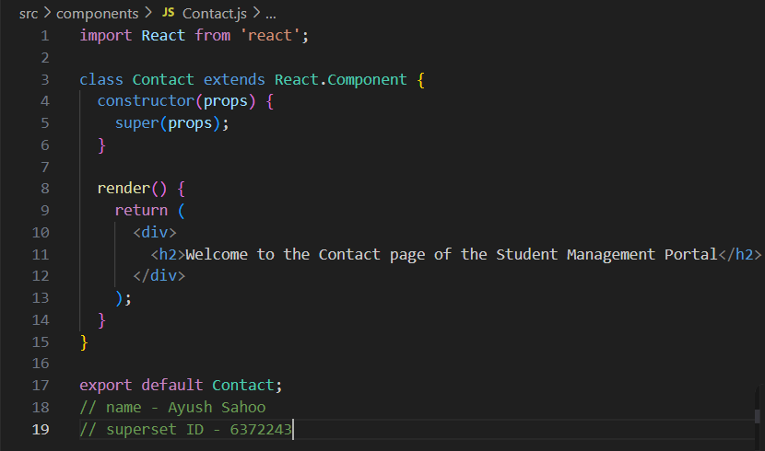

Step 3: Edit “App.js” code.

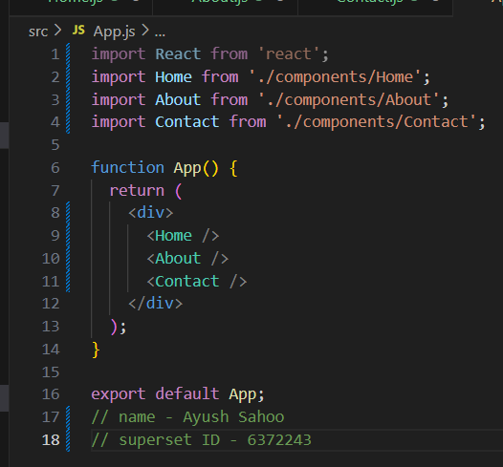

Step 4: C:\Users\ayush\studentpp>npm start

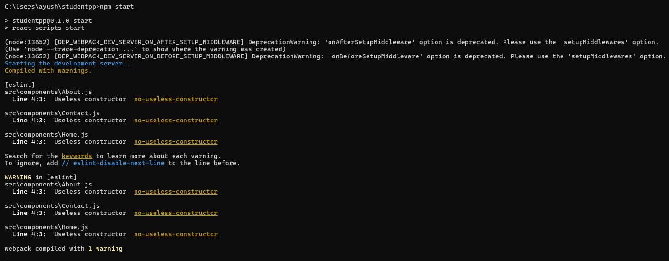

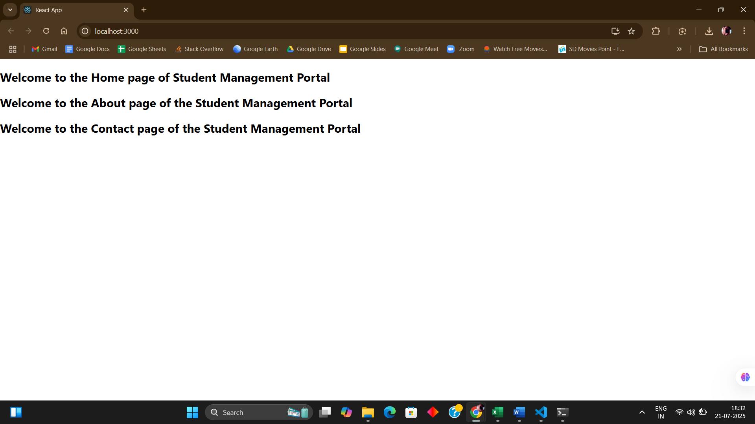

**EXERCISE 3:**

**Create a react app for Student Management Portal named scorecalculatorapp and create a function component named “CalculateScore” which will accept Name, School, Total and goal in order to calculate the average score of a student and display the same.**

**SOLUTION:**

Step 1: npx create-react-app scorecalculatorapp

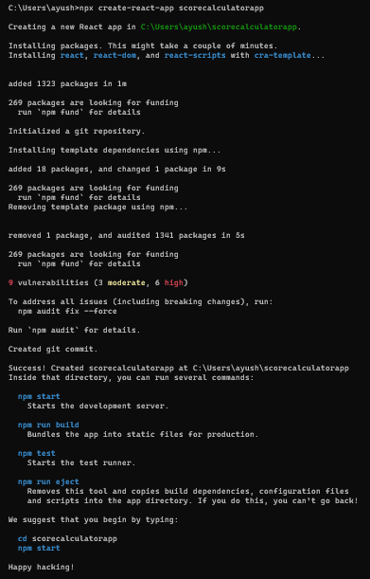

Step 2: Create and code in “CalculateScore.js” file under src folder in “calculatescoreapp”.

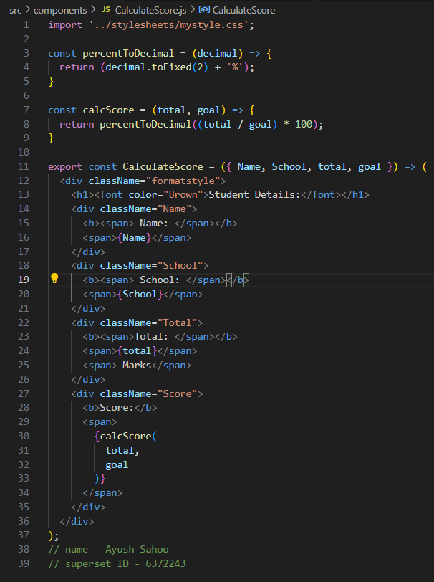

Step 3: Create and code in “mystyle.css” in stylesheet folder.

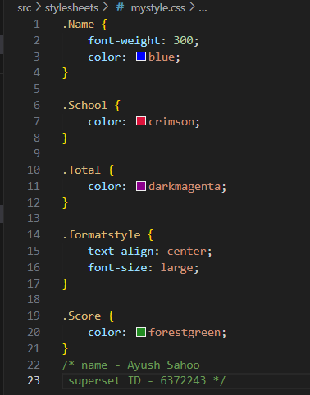

Step 4: Code in “App.js”.

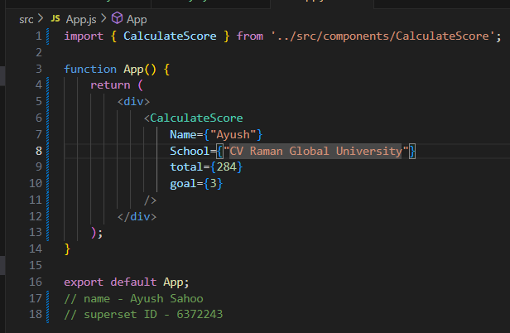

Step 5: C:\Users\ayush\scorecalculatorapp>npm start

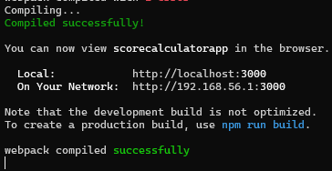

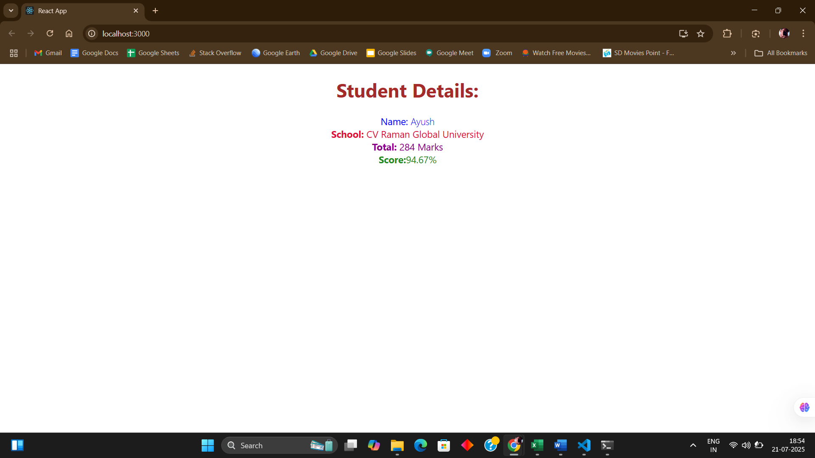

**EXERCISE 4:**

1. **Create a new react application using *create-react-app* tool with the name as “blogapp”**
2. **Open the application using VS Code**
3. **Create a new file named as Post.js in src folder with following properties**
4. **Create a new class based component named as Posts inside Posts.js file**
5. **Initialize the component with a list of Post in state of the component using the constructor**
6. **Create a new method in component with the name as loadPosts() which will be responsible for using Fetch API and assign it to the component state created earlier. To get the posts use the url (**[**https://jsonplaceholder.typicode.com/posts**](https://jsonplaceholder.typicode.com/posts)**)**
7. **Implement the componentDidMount() hook to make calls to loadPosts() which will fetch the posts**
8. **Implement the render() which will display the title and post of posts in html page using heading and paragraphs respectively**
9. **Define a componentDidCatch() method which will be responsible for displaying any error happing in the component as alert messages**
10. **Add the Posts component to App component.**
11. **Build and Run the application using *npm start* command**

**SOLUTION:**

Step 1: C:\Users\ayush>npx create-react-app blogapp

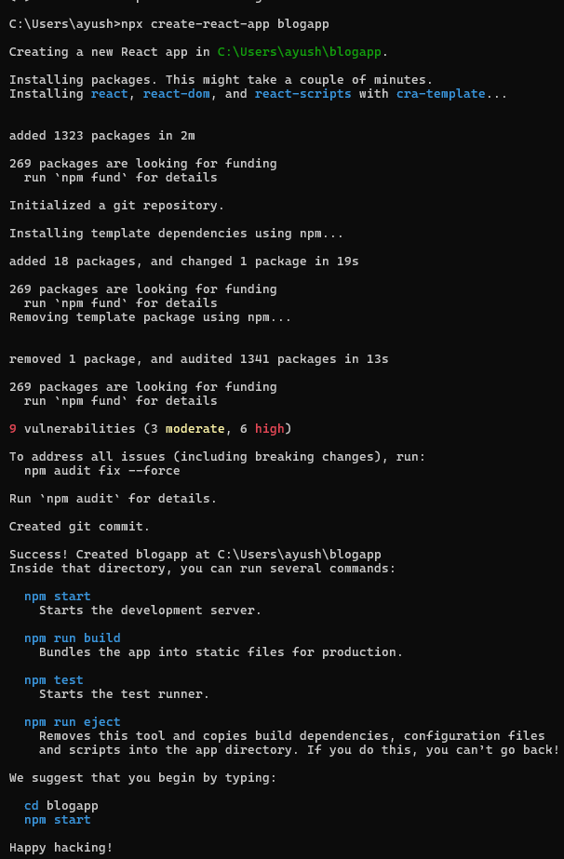

Step 2: Create “Post.js” in src folder under “blogapp”.

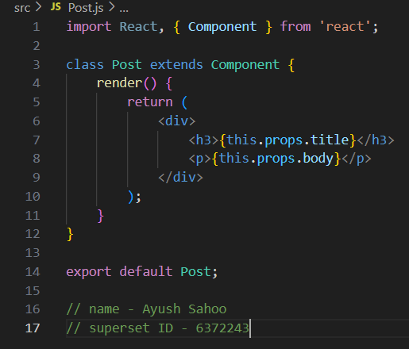

Step 3: Create “Post.js” in src folder under “blogapp”.

(Here I have done every step like creating method like **loadPosts(), componentDidMount(),** and also implementing **render(), componentDidCatch()** )

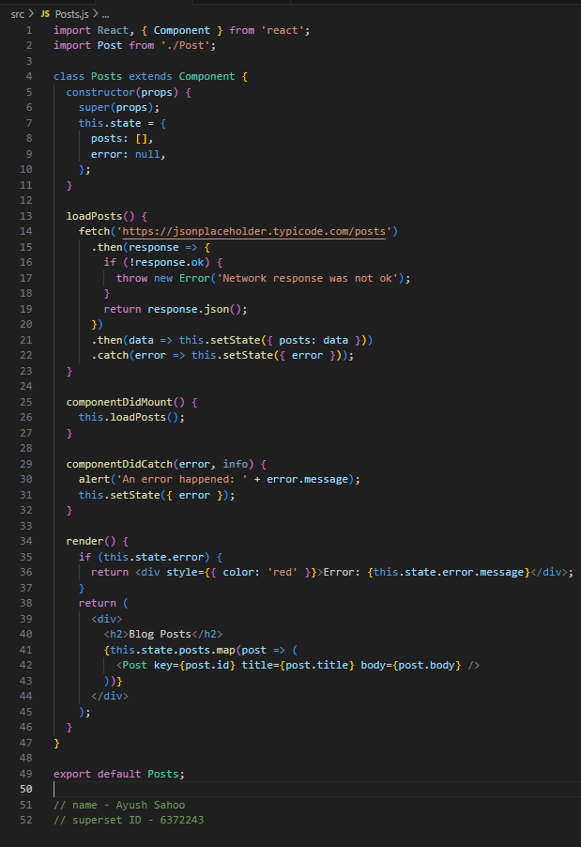

Step 4: Code in “App.js” under src folder of “blogapp”.

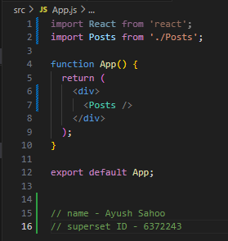

Step 5: C:\Users\ayush\blogapp>npm start

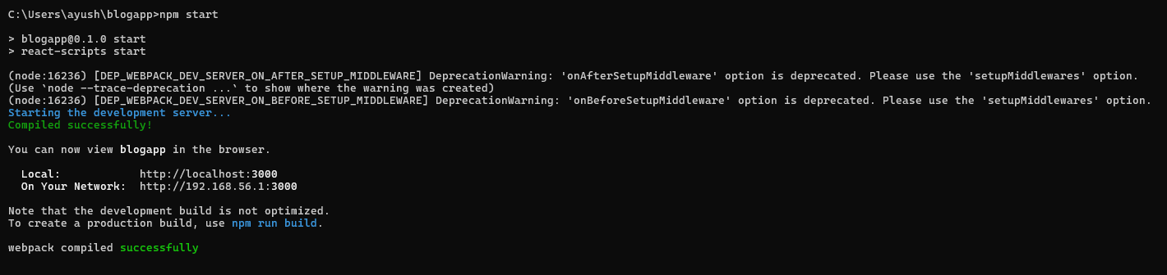

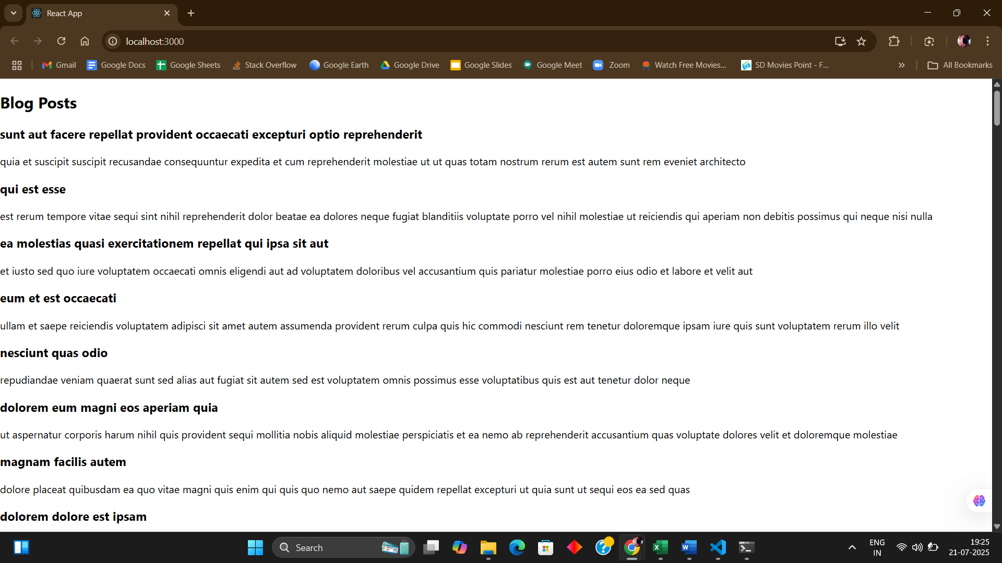

**EXERCISE 5:**

**My Academy team at Cognizant want to create a dashboard containing the details of ongoing and completed cohorts. A react application is created which displays the detail of the cohorts using react component. You are assigned the task of styling these react components.**

**SOLUTION:**

Step 1: Download and unzip the file/folder

Step 2: In cmd prompt “ C:\Users\ayush\Downloads\cohorttracker>npm install “

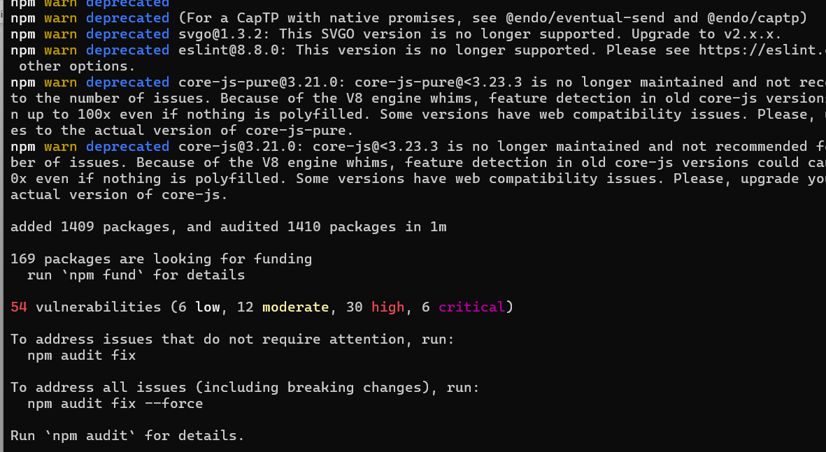

Step 3: In src folder of “cohorttracker” create a file name “CohortDetails.module.css”

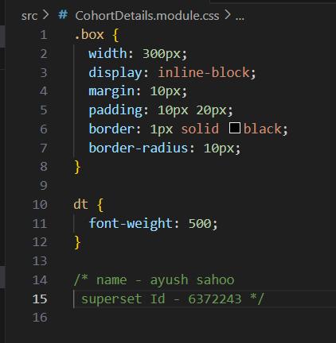

Step 4: In file “CohortDetails.js“ write the code

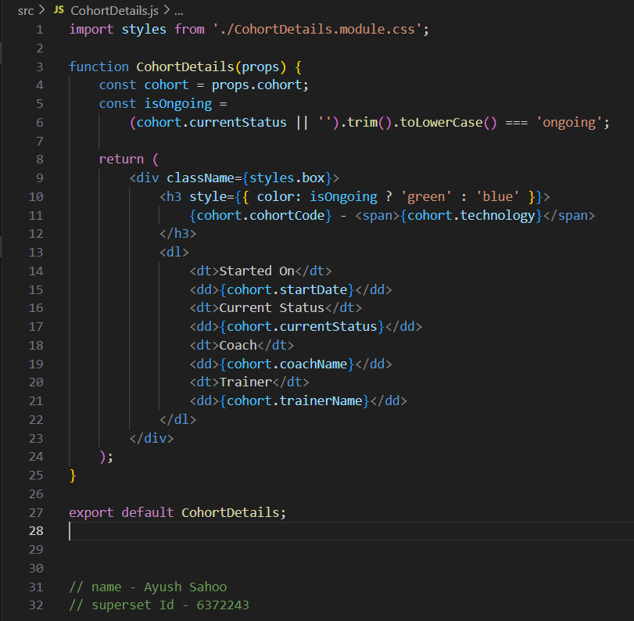

Step 6:

C:\Users\ayush\Downloads\cohorttracker>npm start

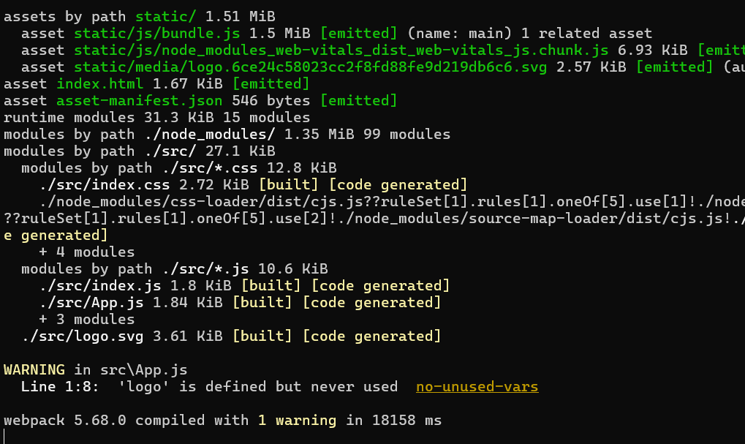

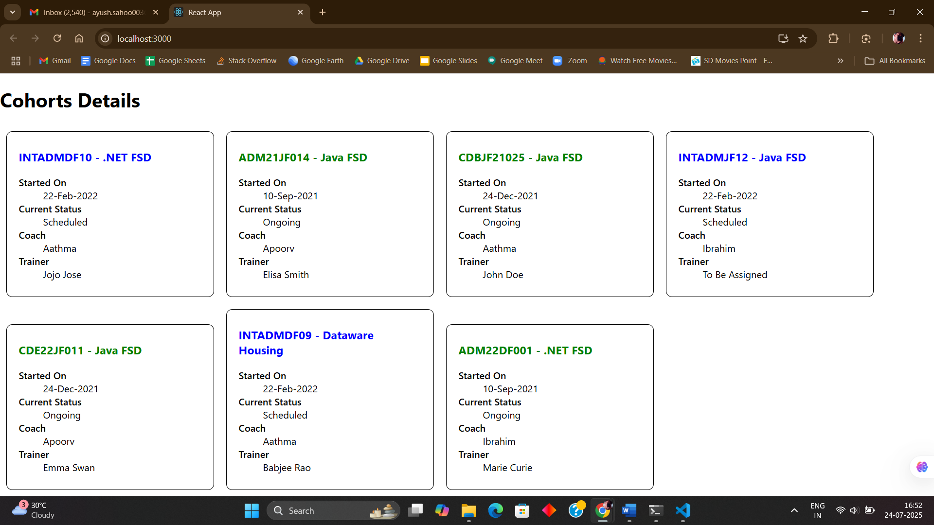

ADDITIONAL HANDS ON

**EXERCISE 6:**

**Cognizant Academy teams want to maintain a list of trainers along with their expertise in a SPA using React as the technology. You are assigned the task of creating this React app.**

**The following trainers’ data application will deal.**

1. **T-ID**
2. **Name**
3. **Phone**
4. **Email**
5. **Stream**
6. **Skills**

**SOLUTION:**

Step 1: C:\Users\ayush>npx create-react-app trainersapp

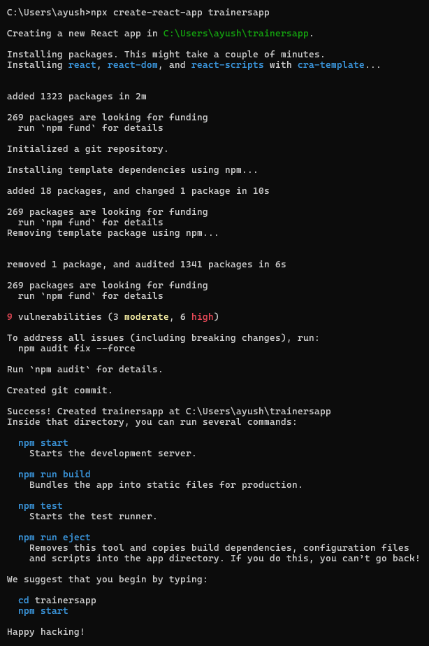

Step 2: Create “trainer.js” under src folder of “trainersapp”.

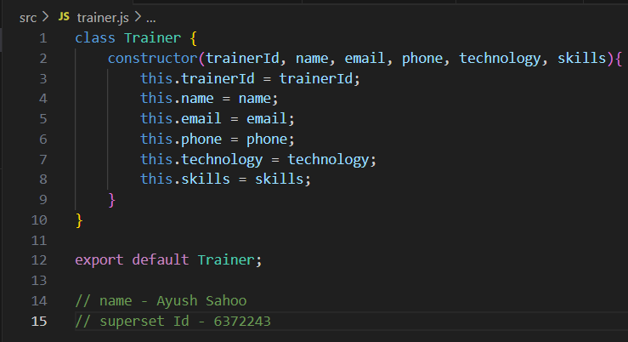

Step 3: Create “trainersmmock.js” under src folder of “trainersapp”.

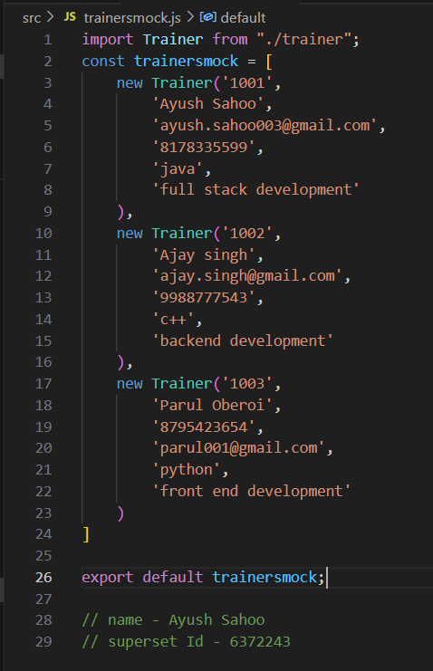

Step 4: Create “trainerslist.js” under src folder of “trainersapp”.

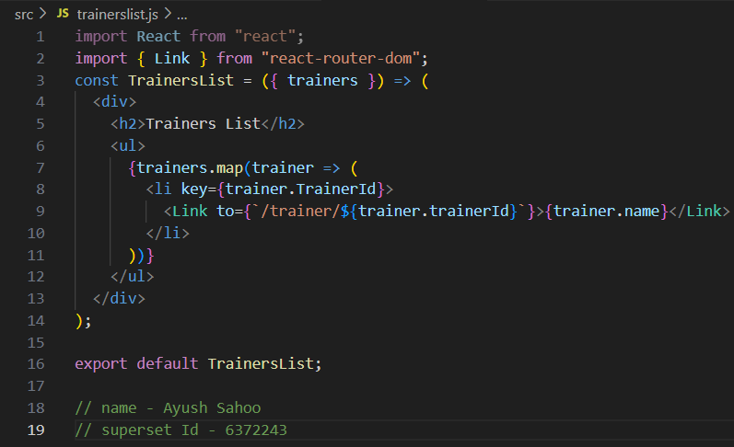

Step 5: Create “home.js” under src folder of “trainersapp”.

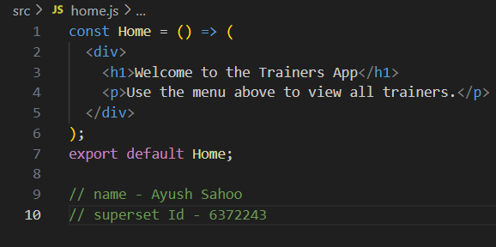

Step 6: Create “trainersdetail.js” under src folder of “trainersapp”.

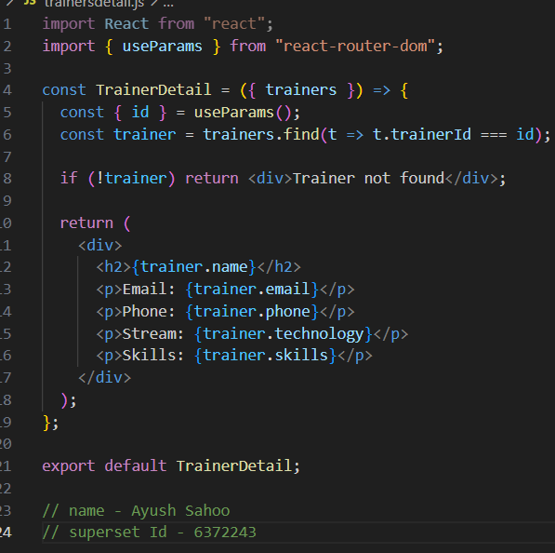

Step 7: Create “App.js” under src folder of “trainersapp”.

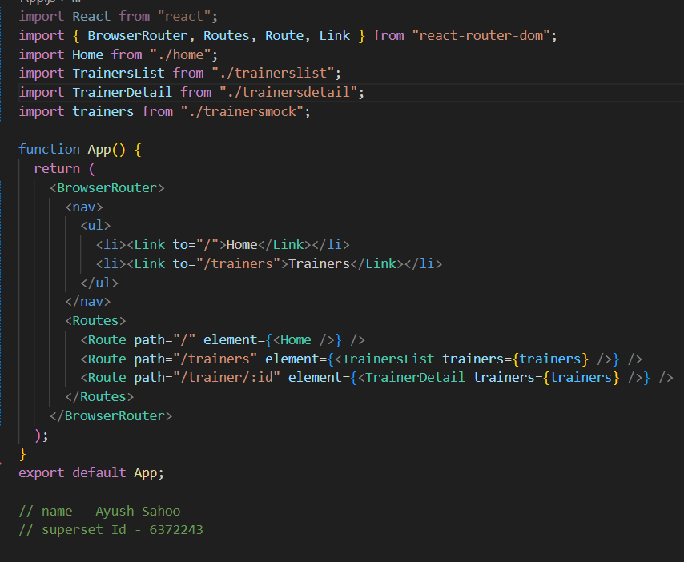

Step 8: C:\Users\ayush\trainersapp>npm install react-router-dom@6

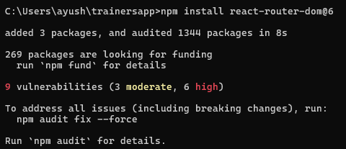

Step 9: C:\Users\ayush\trainersapp>npm start

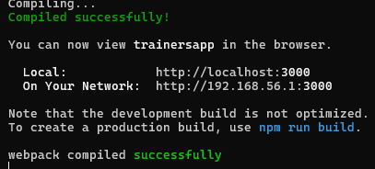

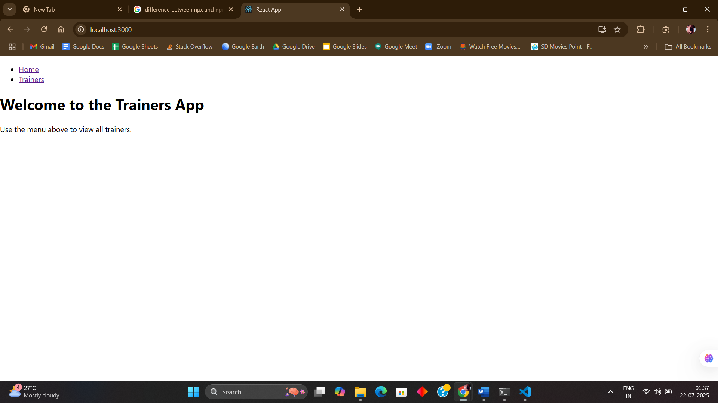

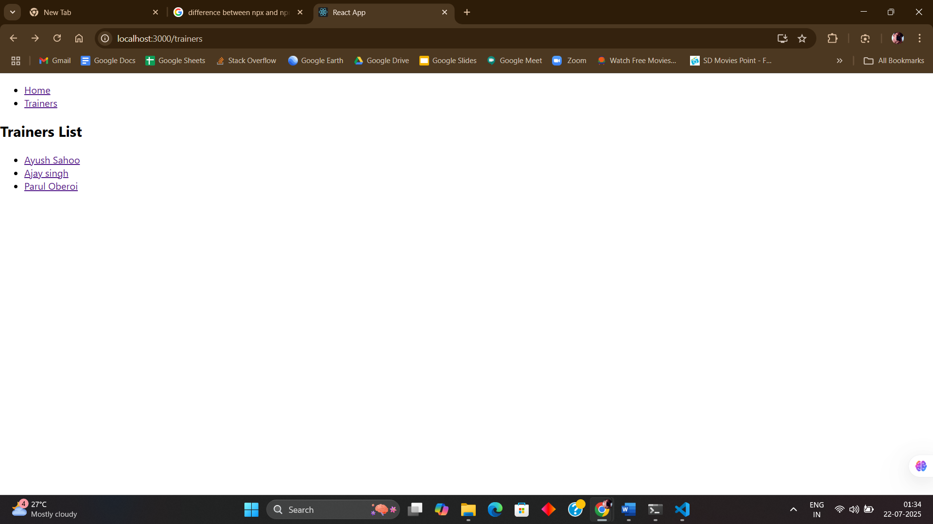

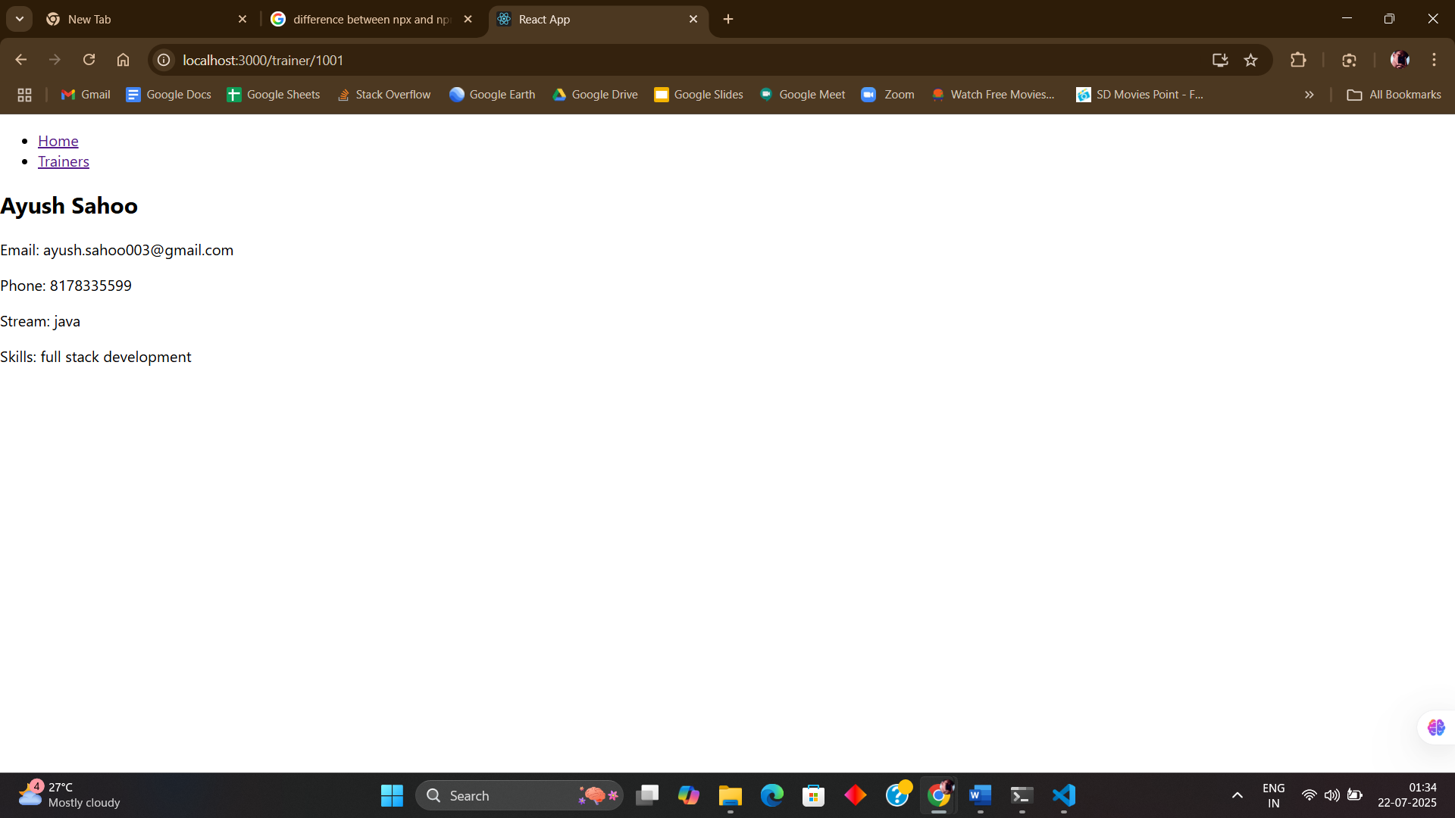

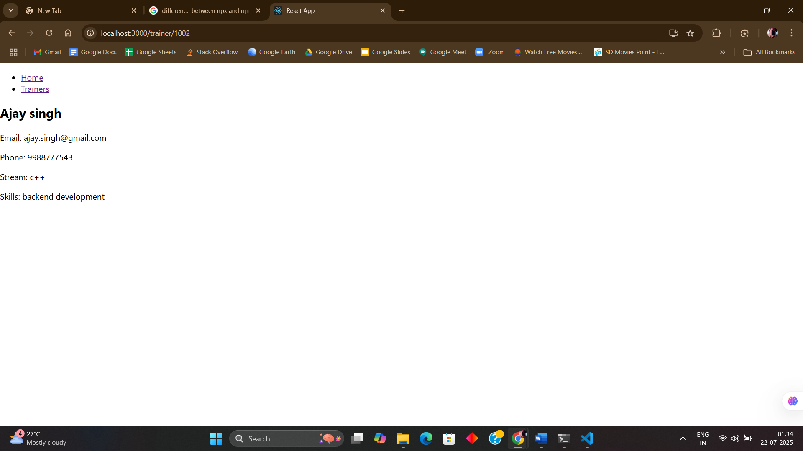

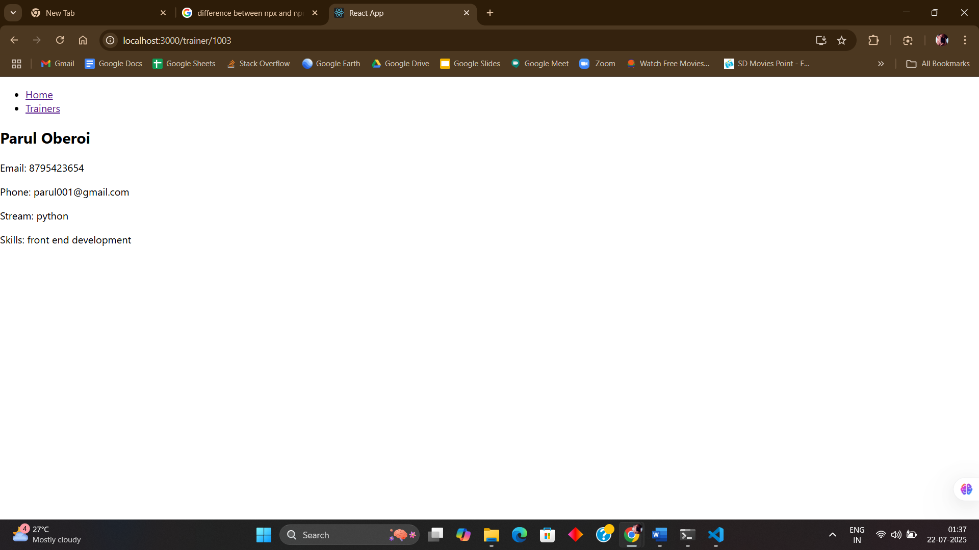

**EXERCISE 8:**

**Create a React App “counterapp” which will have a component named “CountPeople” which will have 2 methods.**

**UpdateEntry() 🡪 which will display the number of people who entered the mall.**

**UpdateExit() 🡪 which will display the number of people who exited the mall.**

**Use Constructor and state to Store the entrycount and exitcount.**

**SOLUTION:**

Step 1: C:\Users\ayush>npx create-react-app counterapp

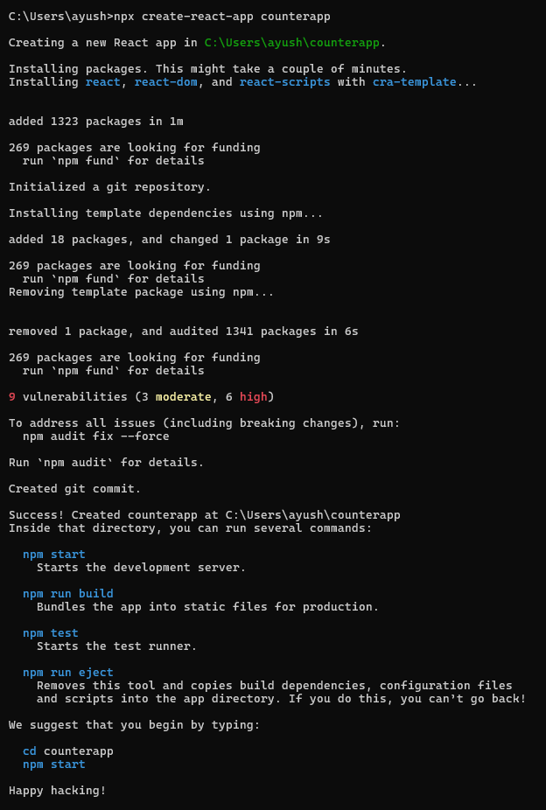

Step 2: Create “CountPeople.js” under src folder.

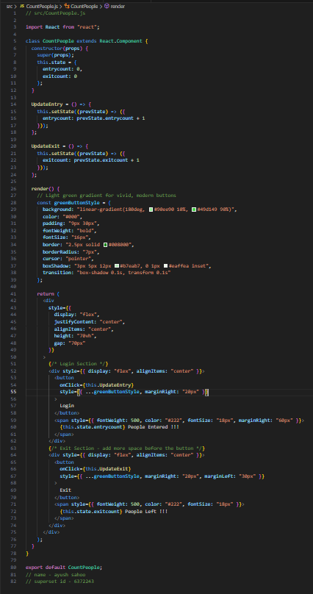

Step 3: update “App.js”

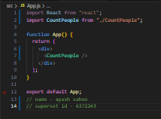

Step 3: Update “index.css”

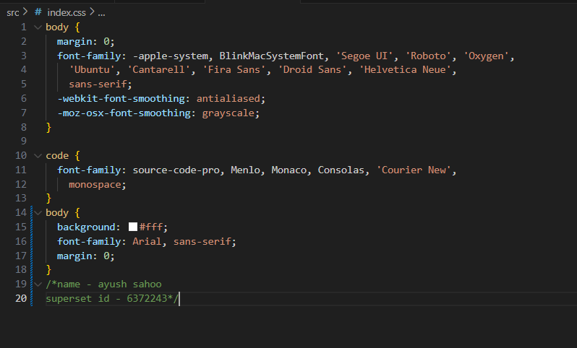

Step 4: C:\Users\ayush\counterapp>npm start

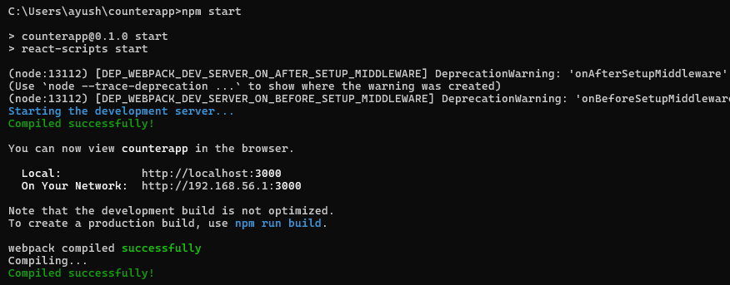

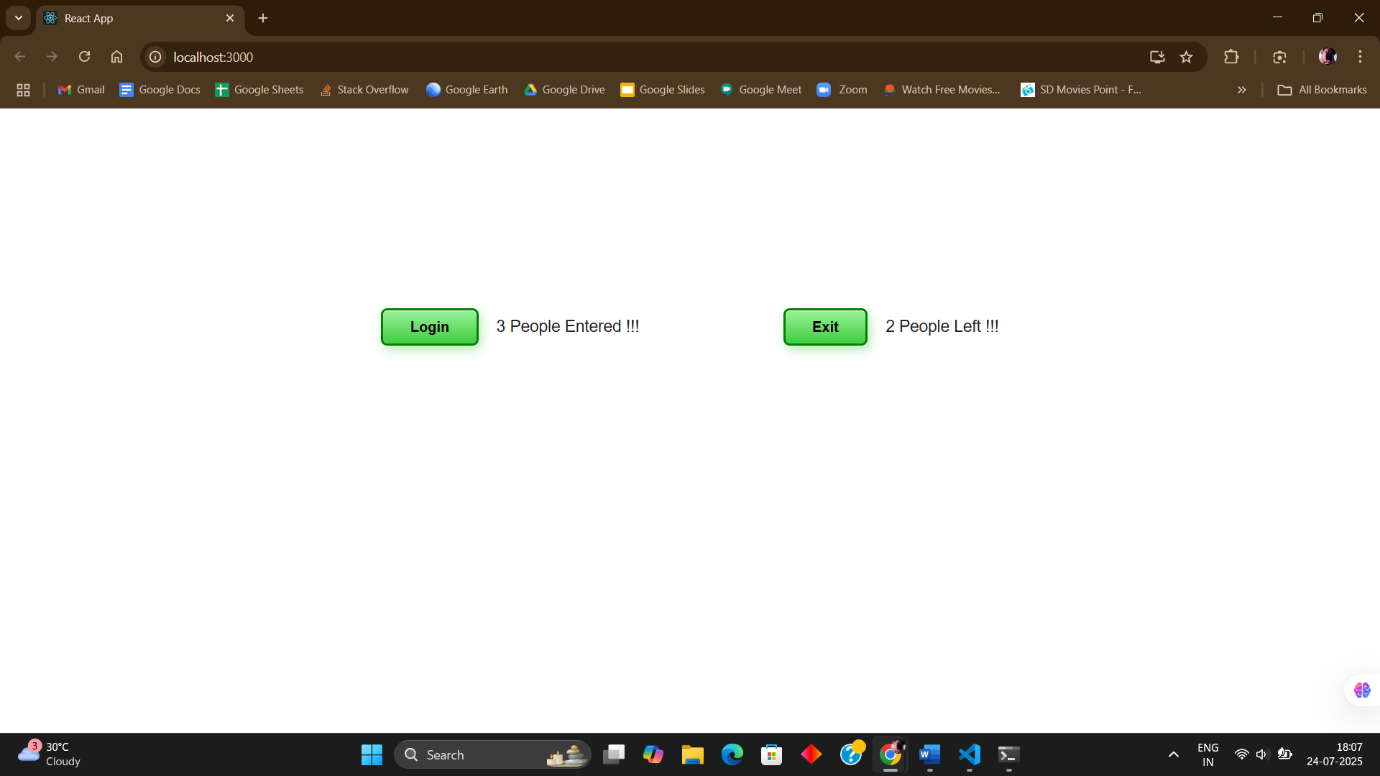

**x----x----x**